# Network Simulation

# Lab Reports

# Submitted by:

# Ateeq ur rehman

# Registration No. : 12PWCSE0976

# Submitted to:

# Dr. Safdar Nawaz Khan Marwat

**Lab 1**

**Project and Node Editors in OPNET to set up queue**

**Models (M/M/1, M/G/1 and M/D/1)**

Average Queue size M/M/1:

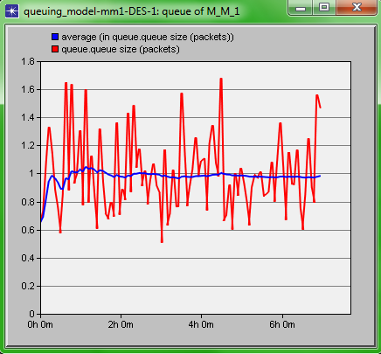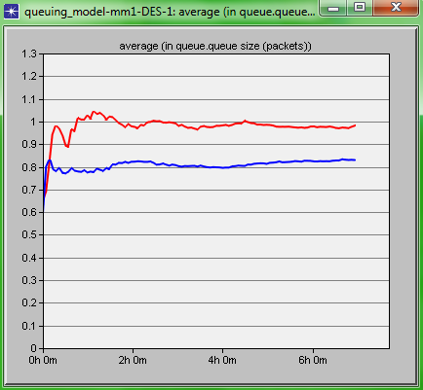

**Task 1**

Compare the queuing delay (sec) and queue size (packets) with previous two scenarios.

|  |  |  |  |  |
| --- | --- | --- | --- | --- |
|  | **M/M/1** | **M/G/1** | **M/D/1** | |
| **Average system**  **Delay (sec)** | 1.9465 | 1.675 | 1.514 | |
| **Average number of**  **packets in the**  **system(Packets)** | 0.9898 | 0.85 | 0.7595 | |
| **Theoretical calculations** | | | | |
| **Average system**  **Delay (sec)** | 2 | 1.654 | | 1.5 |
| **Average number of**  **packets in the system(Packets)** | 1.2 | 1.35 | | 0.765 |

**Task 2**

**Set up an M/M/1/N queue with finite buffer.**

**1. How to get the ratio of overflow?**

No. of packets=12,600 (with the rate of 1 packet in 2 sec for 7 hours)

Packets Overflow=103

% packets overflown=0.6%

Overflow ratio=83/12600

**2. Which is the maximum queue size?**

Max queue size is 6

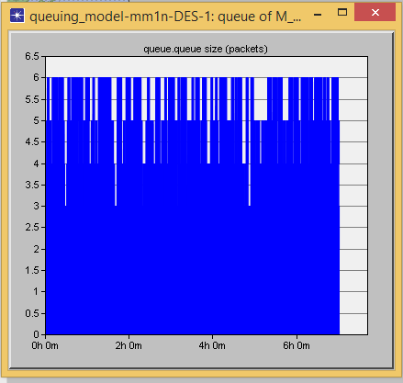

**3. How are its CDF and PMF?**

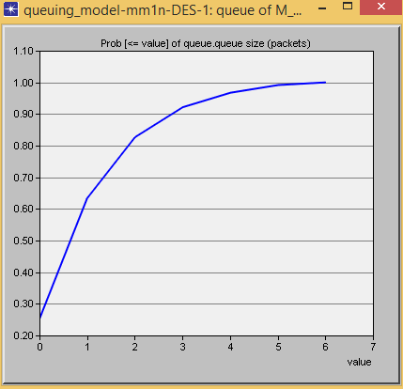

**4. Compare the results of queue delay mm1 scenario**

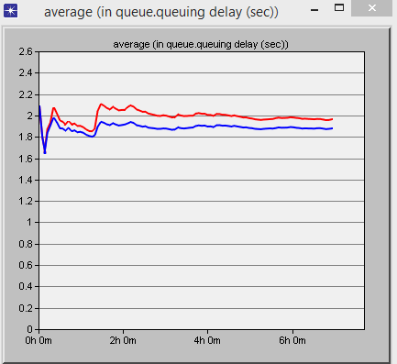

**Lab 2**

**Application Configuration with Ethernet Server and Workstation.**

FTP Application Configuration

Choosing statistics and collecting results

Choose the statistics as shown in Table and run the simulation for 3000 seconds0.

|  |  |  |
| --- | --- | --- |
| **Node statistics (workstation)** | | **Average value** |
| Client FTP | Download File Size (bytes) | 1000 |
| Download Response Time (sec) | 0.15 |
| TCP | Segment delay (sec) | 0.029 |
| Load (bytes/sec) | 0.51 |
| Traffic received (bytes/sec) | 1.00 |
| **Link statistics** | |  |
| Point-to-point | Throughput (bits/sec) → | 10.8 |
| Throughput (bits/sec) ← | 7.50 |

Table 1: Choosing statistics and collecting result

Table 2: Setting up scenarios A and B values:

|  |  |  |  |  |
| --- | --- | --- | --- | --- |
| **Scenario** | | **A** | **B** | |
| **Node statistics (workstation)** | | **Average value** | | |
| Client FTP | Download File Size (bytes) | 0.67 | | 0.6134 |
| Download Response Time (sec) | 0.065 | | 0.054 |
| TCP | Segment delay (sec) |  | |  |
| Load (bytes/sec) | 4123.0734 | | 4333.456 |
| Traffic received (bytes/sec) | 1 | | 5261.56 |
| **Link statistics** | |  | |  |
| Point-to-point | Throughput (bits/sec) | 21.44 | | 6914.98 |
| Throughput (bits/sec) | 44.56 | | 6034.56 |

Switch scenario results:

|  |  |  |
| --- | --- | --- |
| **Global Statistics** |  | **Average value** |
| FTP | Download Response Time (sec) | 0.55 |
| Upload Response Time (sec) | 0.54 |
| Traffic Received (bytes/sec) | 0.50 |
| Traffic Sent (bytes/sec) | 0.50 |
| TCP | Segment Delay | 0.91 |
| **Link statistics** |  |  |
| Point-to-point | Throughput (bits/sec) → | 50 |
|  | Throughput (bits/sec) | 40 |

Table 4: Switch Parameters**.**

Point to Point Statistics:

|  |  |  |
| --- | --- | --- |
| (switch< --->workstation_1) | Throughput (bits/sec) | 14.24 |
| Throughput (bits/sec) | 8.74 |
| (switch< -- >workstation_2) | Throughput (bits/sec) | 14.04 |
| Throughput (bits/sec) | 8.38 |
| (switch< -- >workstation_3) | Throughput (bits/sec) | 14.37 |
| Throughput (bits/sec) | 10.1 |
| Point-to-point  (switch< -- >workstation_4) | Throughput (bits/sec) | 14.04 |
| Throughput (bits/sec) | 8.38 |
| Point-to-point  (switch< -- >workstation_5) | Throughput (bits/sec)🡪 | 12.65 |
| Throughput (bits/sec) 🡨 | 14.93 |
| Point-to-point  (switch< -- >workstation_6) | Throughput (bits/sec)🡪 | 9.67 |
| Throughput (bits/sec) 🡨 | 12.75 |

**Lab 3**

**Process Model Development with Embedded C Language Code and Packet Format.**

**Finite State Machine:**

Traffic sink, end-to-end delay and Received:

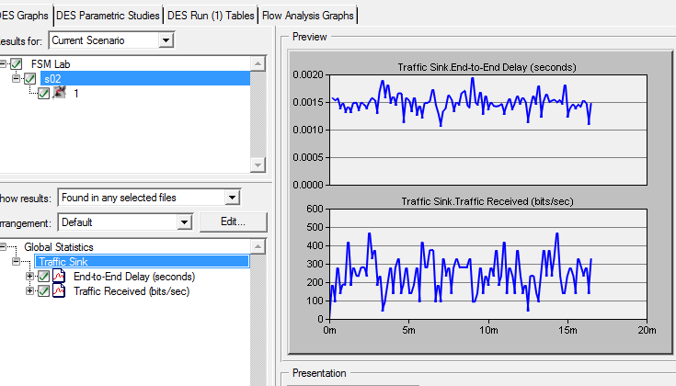

**Packet Format:**

Packet overhead:

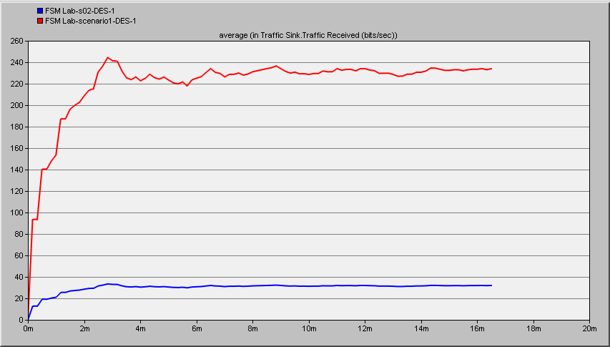

no packet overhead results:

